Heart disease occurs when plaque develops in the arteries and blood vessels that lead to the heart. This blocks important

nutrients and oxygen from reaching your heart. Plaque is a waxy

substance made up of cholesterol, fatty molecules, and minerals.Feb 16, 2016

Heart disease describes a range of conditions that affect your heart. Diseases under the heart disease umbrella include blood vessel diseases, such as coronary

artery disease; heart rhythm problems (arrhythmias); and heart defects you're born with (congenital heart defects), among others.

The term "heart disease" is often used interchangeably with the term "cardiovascular disease." Cardiovascular disease generally refers to conditions

that involve narrowed or blocked blood vessels that can lead to a heart attack, chest pain (angina) or stroke. Other heart conditions, such as those that

affect your heart's muscle, valves or rhythm, also are considered forms of heart disease.

Many forms of heart disease can be prevented or treated with healthy lifestyle choices.

Symptoms of heart disease in your blood vessels (atherosclerotic disease)

Cardiovascular disease symptoms may be different for men and women. For instance, men are more likely to have chest pain; women are more likely

to have other

symptoms along with chest discomfort, such as shortness of breath, nausea and extreme fatigue.

Symptoms can include:

Chest pain, chest tightness, chest pressure and chest discomfort (angina)

Shortness of breath

Pain, numbness, weakness or coldness in your legs or arms if the blood vessels in those parts of your body are narrowed

Pain in the neck, jaw, throat, upper abdomen or back

You might not be diagnosed with cardiovascular disease until you have a heart attack, angina, stroke or heart failure. It's important to watch for cardiovascular

symptoms and discuss concerns with your doctor. Cardiovascular disease can sometimes be found early with regular evaluations.

Heart disease symptoms caused by abnormal heartbeats (heart arrhythmias)

A heart arrhythmia is an abnormal heartbeat. Your heart may beat too quickly, too slowly or irregularly. Heart arrhythmia symptoms can include:

Fluttering in your chest

Racing heartbeat (tachycardia)

Slow heartbeat (bradycardia)

Chest pain or discomfort

Shortness of breath

Lightheadedness

Dizziness

Fainting (syncope) or near fainting

Heart disease symptoms caused by heart defects

Serious congenital heart defects — defects you're born with — usually become evident soon after birth. Heart defect symptoms in children could include:

Pale gray or blue skin color (cyanosis)

Swelling in the legs, abdomen or areas around the eyes

In an infant, shortness of breath during feedings, leading to poor weight gain

Less serious congenital heart defects are often not diagnosed until later in childhood or during adulthood. Signs and symptoms of congenital heart

defects that usually aren't immediately life-threatening include:

Easily getting short of breath during exercise or activity

Easily tiring during exercise or activity

Swelling in the hands, ankles or feet

Heart disease symptoms caused by weak heart muscle (dilated cardiomyopathy)

In early stages of cardiomyopathy, you may have no symptoms. As the condition worsens, symptoms may include:

Breathlessness with exertion or at rest

Swelling of the legs, ankles and feet

Fatigue

Irregular heartbeats that feel rapid, pounding or fluttering

Dizziness, lightheadedness and fainting

Heart disease symptoms caused by heart infections

Endocarditis is an infection that affects the inner membrane that separates the chambers and valves of the heart (endocardium). Heart infection

symptoms can include:

Fever

Shortness of breath

Weakness or fatigue

Swelling in your legs or abdomen

Changes in your heart rhythm

Dry or persistent cough

Skin rashes or unusual spots

Heart disease symptoms caused by valvular heart disease

The heart has four valves — the aortic, mitral, pulmonary and tricuspid valves — that open and close to direct blood flow through your heart. Valves may be

damaged by a variety of conditions leading to narrowing (stenosis), leaking (regurgitation or insufficiency) or improper closing (prolapse).

Depending on which valve isn't working properly, valvular heart disease symptoms generally include:

Fatigue

Shortness of breath

Irregular heartbeat

Swollen feet or ankles

Chest pain

Fainting (syncope)

When to see a doctor

Seek emergency medical care if you have these heart disease symptoms:

Chest pain

Shortness of breath

Fainting

Heart disease is easier to treat when detected early, so talk to your doctor about your concerns regarding your heart health. If you're concerned about developing

heart disease, talk to your doctor about steps you can take to reduce your heart disease risk. This is especially important if you have a family history of heart

disease.

If you think you may have heart disease, based on new signs or symptoms you're having, make an appointment to see your doctor.

Request an Appointment at Mayo Clinic

Causes

How the heart works

Chambers and valves of the heart

Chambers and valves of the heart

Your heart is a pump. It's a muscular organ about the size of your fist, situated slightly left of center in your chest. Your heart is divided into the right

and the left side. The division prevents oxygen-rich blood from mixing with oxygen-poor blood. Oxygen-poor blood returns to the heart after circulating through your

body.

The right side of the heart, comprising the right atrium and ventricle, collects and pumps blood to the lungs through the pulmonary arteries.

The lungs refresh the blood with a new supply of oxygen. The lungs also breathe out carbon dioxide, a waste product.

Oxygen-rich blood then enters the left side of the heart, comprising the left atrium and ventricle.

The left side of the heart pumps blood through the aorta to supply tissues throughout the body with oxygen and nutrients.

Heart valves

Four valves within your heart keep your blood moving the right way by opening only one way and only when they need to. To function properly, the valve must be

formed properly, must open all the way and must close tightly so there's no leakage. The four valves are:

Tricuspid

Mitral

Pulmonary

Aortic

Heartbeats

The blueprints to your heart

Click here for an infographic to learn more

A beating heart contracts and relaxes in a continuous cycle.

During contraction (systole), your ventricles contract, forcing blood into the vessels to your lungs and body.

During relaxation (diastole), the ventricles are filled with blood coming from the upper chambers (left and right atria).

Electrical system

Your heart's electrical wiring keeps it beating, which controls the continuous exchange of oxygen-rich blood with oxygen-poor blood. This exchange keeps you alive.

Electrical impulses begin high in the right atrium and travel through specialized pathways to the ventricles, delivering the signal for the heart to pump.

The conduction system keeps your heart beating in a coordinated and normal rhythm, which keeps blood circulating.

Various heart disease causes

The causes of heart disease vary by type of heart disease.

Causes of cardiovascular disease

Development of atherosclerosis

Development of atherosclerosis

While cardiovascular disease can refer to different heart or blood vessel problems, the term is often used to mean damage to your heart or blood vessels by

atherosclerosis (ath-ur-o-skluh-ROE-sis), a buildup of fatty plaques in your arteries. Plaque buildup thickens and stiffens artery walls, which can inhibit blood

flow through your arteries to your organs and tissues.

Atherosclerosis is also the most common cause of cardiovascular disease. It can be caused by correctable problems, such as an unhealthy diet, lack of exercise,

being overweight and smoking.

Causes of heart arrhythmia

Common causes of abnormal heart rhythms (arrhythmias) or conditions that can lead to arrhythmias include:

Heart defects you're born with (congenital heart defects)

Coronary artery disease

High blood pressure

Diabetes

Smoking

Excessive use of alcohol or caffeine

Drug abuse

Stress

Some over-the-counter medications, prescription medications, dietary supplements and herbal remedies

Valvular heart disease

In a healthy person with a normal, healthy heart, it's unlikely for a fatal arrhythmia to develop without some outside trigger, such as an electrical shock or the

use of illegal drugs. That's primarily because a healthy person's heart is free from any abnormal conditions that cause an arrhythmia, such as an area of scarred

tissue.

However, in a heart that's diseased or deformed, the heart's electrical impulses may not properly start or travel through the heart, making arrhythmias more

likely to develop.

Causes of congenital heart defects

Congenital heart defects usually develop while a baby is in the womb. Heart defects can develop as the heart develops, about a month after conception, changing the

flow of blood in the heart. Some medical conditions, medications and genes may play a role in causing heart defects.

Heart defects can also develop in adults. As you age, your heart's structure can change, causing a heart defect.

Causes of cardiomyopathy

The cause of cardiomyopathy, a thickening or enlarging of the heart muscle, may depend on the type:

Dilated cardiomyopathy. The cause of this most common type of cardiomyopathy often is unknown. It may be caused by reduced blood flow to the heart (ischemic heart

disease) resulting from damage after a heart attack, infections, toxins and certain drugs. It may also be inherited from a parent. It usually enlarges (dilates) the

left ventricle.

Hypertrophic cardiomyopathy. This type, in which the heart muscle becomes abnormally thick, usually is inherited. It can also develop over time because of high blood

pressure or aging.

Restrictive cardiomyopathy. This least common type of cardiomyopathy, which causes the heart muscle to become rigid and less elastic, can occur for no known

reason.

Or it may be caused by diseases, such as connective tissue disorders, excessive iron buildup in your body (hemochromatosis), the buildup of abnormal proteins

(amyloidosis) or by some cancer treatments.

Causes of heart infection

A heart infection, such as endocarditis, is caused when an irritant, such as a bacterium, virus or chemical, reaches your heart muscle. The most common causes of

heart infection include:

Bacteria

Viruses

Parasites

Causes of valvular heart disease

There are many causes of diseases of your heart valves. You may be born with valvular disease, or the valves may be damaged by conditions such as:

Rheumatic fever

Infections (infectious endocarditis)

Connective tissue disorders

More Information

Heart disease care at Mayo Clinic

Omega-6 fatty acids

Risk factors

Risk factors for developing heart disease include:

Age. Aging increases your risk of damaged and narrowed arteries and weakened or thickened heart muscle.

Sex. Men are generally at greater risk of heart disease. However, women's risk increases after menopause.

Family history. A family history of heart disease increases your risk of coronary artery disease, especially if a parent developed

it at an early age (before age 55 for a male relative, such as your brother or father, and 65 for a female relative, such as your mother or sister).

Smoking. Nicotine constricts your blood vessels, and carbon monoxide can damage their inner lining, making them more susceptible to atherosclerosis.

Heart attacks are more common in smokers than in nonsmokers.

Certain chemotherapy drugs and radiation therapy for cancer. Some chemotherapy drugs and radiation therapies may increase the risk of cardiovascular

disease.

Poor diet. A diet that's high in fat, salt, sugar and cholesterol can contribute to the development of heart disease.

High blood pressure. Uncontrolled high blood pressure can result in hardening and thickening of your arteries, narrowing the vessels through which blood flows.

High blood cholesterol levels. High levels of cholesterol in your blood can increase the risk of formation of plaques and atherosclerosis.

Diabetes. Diabetes increases your risk of heart disease. Both conditions share similar risk factors, such as obesity and high blood pressure.

Obesity. Excess weight typically worsens other risk factors.

Physical inactivity. Lack of exercise also is associated with many forms of heart disease and some of its other risk factors, as well.

Stress. Unrelieved stress may damage your arteries and worsen other risk factors for heart disease.

Poor hygiene. Not regularly washing your hands and not establishing other habits that can help prevent viral or bacterial infections can put you at risk of

heart infections, especially if you already have an underlying heart condition. Poor dental health also may contribute to heart disease.

Complications

Complications of heart disease include:

Heart failure. One of the most common complications of heart disease, heart failure occurs when your heart can't pump enough blood to meet

your body's needs. Heart failure can result from many forms of heart disease, including heart defects, cardiovascular disease, valvular heart disease,

heart infections or cardiomyopathy.

Heart attack. A blood clot blocking the blood flow through a blood vessel that feeds the heart causes a heart attack, possibly damaging or

destroying a part of the heart muscle. Atherosclerosis can cause a heart attack.

Stroke. The risk factors that lead to cardiovascular disease also can lead to an ischemic stroke, which happens when the arteries to your brain are

narrowed or blocked so that too little blood reaches your brain. A stroke is a medical emergency — brain tissue begins to die within just a few minutes of a stroke.

Aneurysm. A serious complication that can occur anywhere in your body, an aneurysm is a bulge in the wall of your artery. If an aneurysm bursts,

you may face life-threatening internal bleeding.

Peripheral artery disease. Atherosclerosis also can lead to peripheral artery disease. When you develop peripheral artery disease, your extremities — usually your

legs — don't receive enough blood flow. This causes symptoms, most notably leg pain when walking (claudication).

Sudden cardiac arrest. Sudden cardiac arrest is the sudden, unexpected loss of heart function, breathing and consciousness,

often caused by an arrhythmia. Sudden cardiac arrest is a medical emergency. If not treated immediately, it is fatal, resulting in sudden cardiac death.

More Information

Heart disease care at Mayo Clinic

Flu shots and heart disease

Prevention

Certain types of heart disease, such as heart defects, can't be prevented. However, you can help prevent many other types of heart disease by making

the same lifestyle changes that can improve your heart disease, such as:

Quit smoking

Control other health conditions, such as high blood pressure, high cholesterol and diabetes

Exercise at least 30 minutes a day on most days of the week

Eat a diet that's low in salt and saturated fat

Maintain a healthy weight

Reduce and manage stress

Practice good hygiene

More Information

Heart disease care at Mayo Clinic

Heart disease prevention

Omega-3 in fish

**Dataset information**- This database contains 14 attributes . In particular, the Cleveland database is the only one

that has been used by ML researchers to this date. The "goal" field refers to the presence of heart disease in the patient.

It is integer valued from 0 (no presence) to 4.

Experiments with the Cleveland database have concentrated on simply attempting to distinguish presence (values 1,2,3,4)

from absence (value 0).

Library used Pandas, numpy, seaborn ,sklearn, joblib ,matplotlib

Pandas is a high-level data manipulation tool developed by Wes McKinney. It is built on the Numpy package and its key data structure is called the DataFrame.

DataFrames allow you to store and manipulate tabular data in rows of

observations and columns of variables.

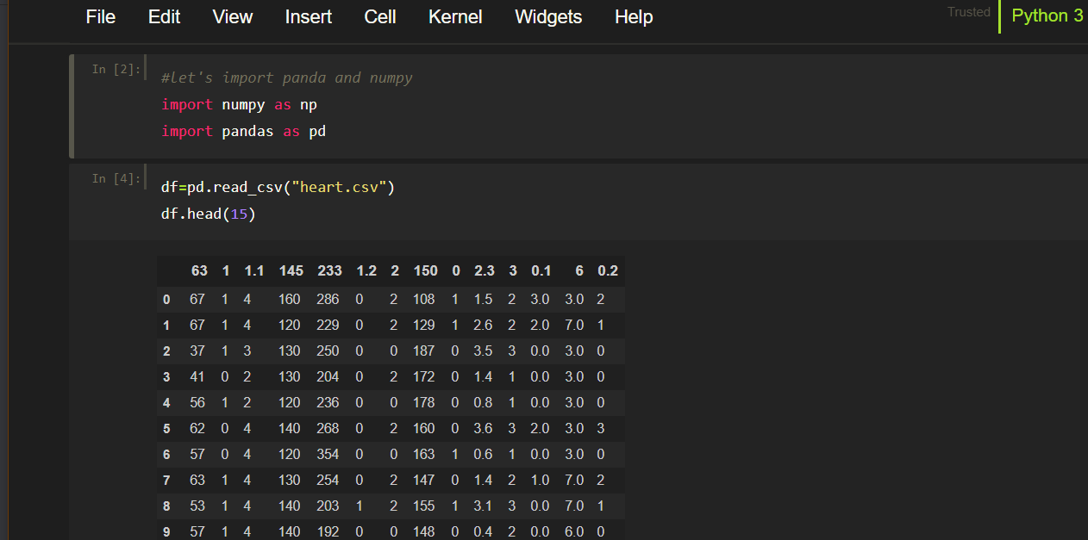

Checking the null values with:

Df.isnull().sum()

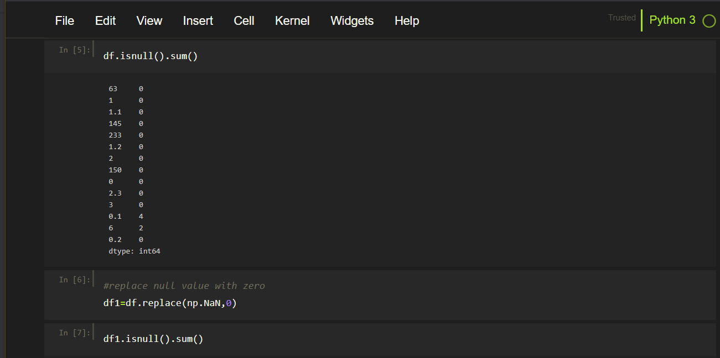

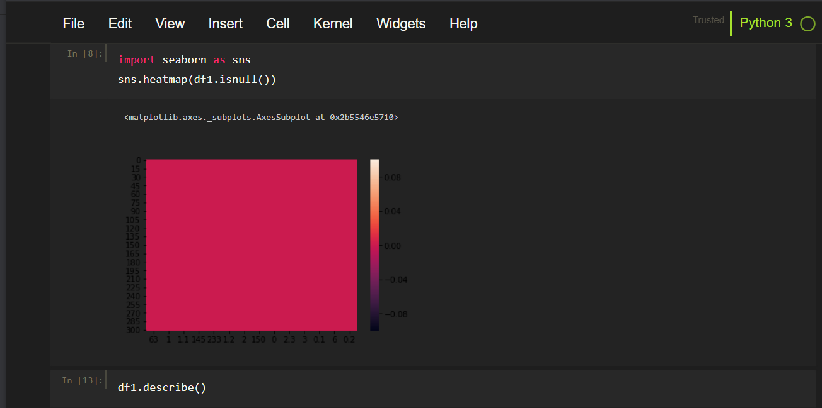

Using a library seabron for visualization

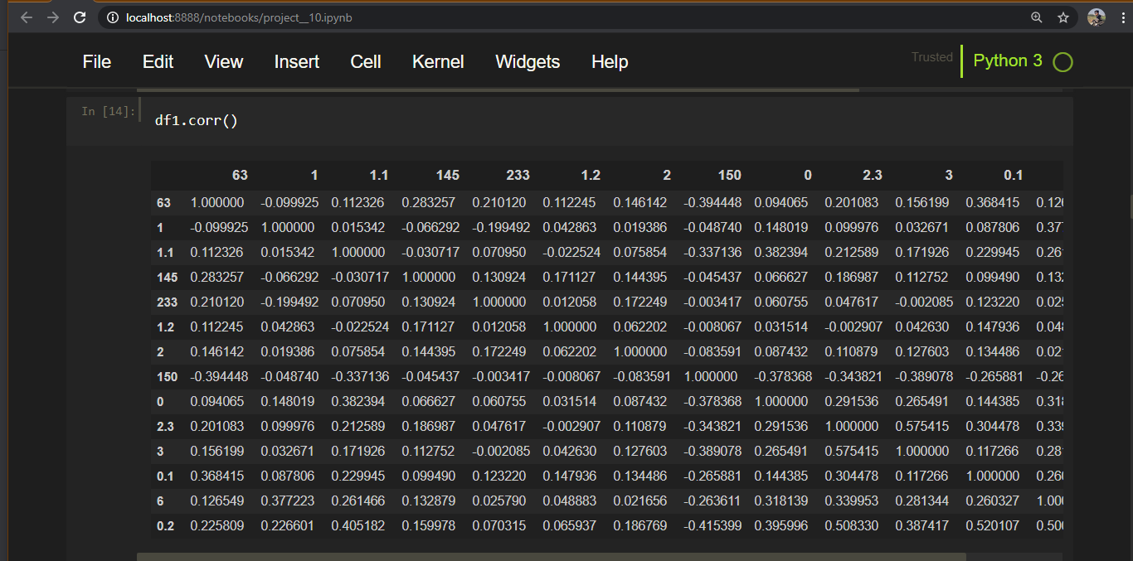

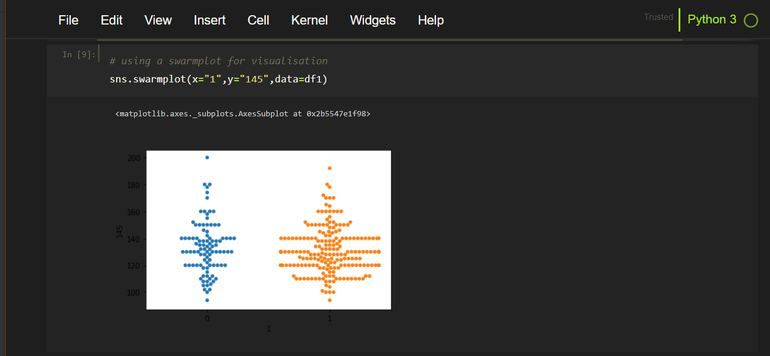

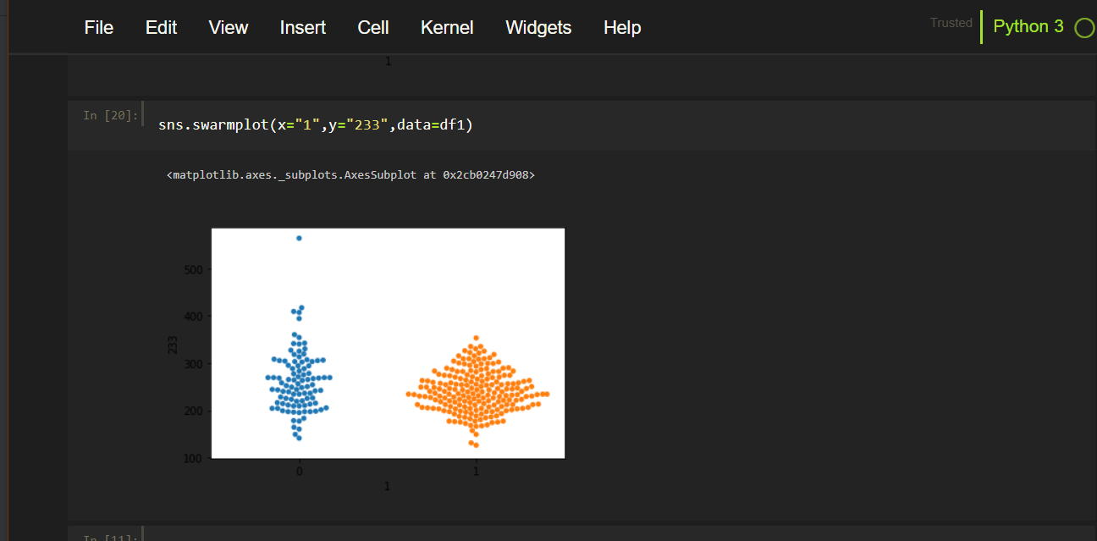

swarmplot. Draw a categorical scatterplot with non-overlapping points. This function is similar to stripplot() , but the points are adjusted (only along the categorical axis) so that they don't overlap.

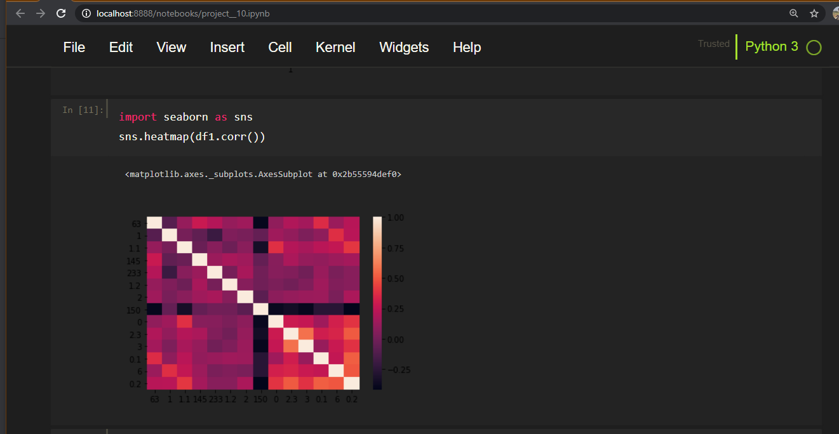

A **scatter plot** (also calleda **scatterplot**, **scatter graph**, **scatter** chart, scattergram, or **scatter diagram**) is a type of **plot** or mathematical **diagram** using Cartesian coordinates to display values for typically two variables for a set of data.

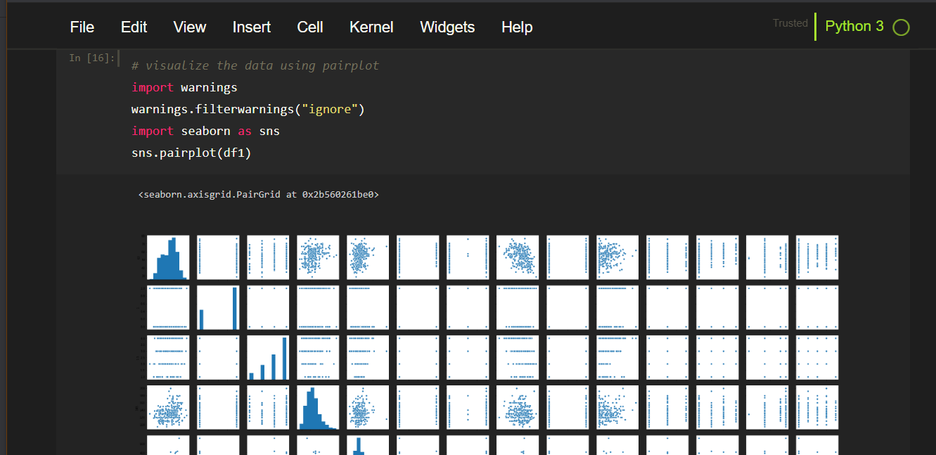

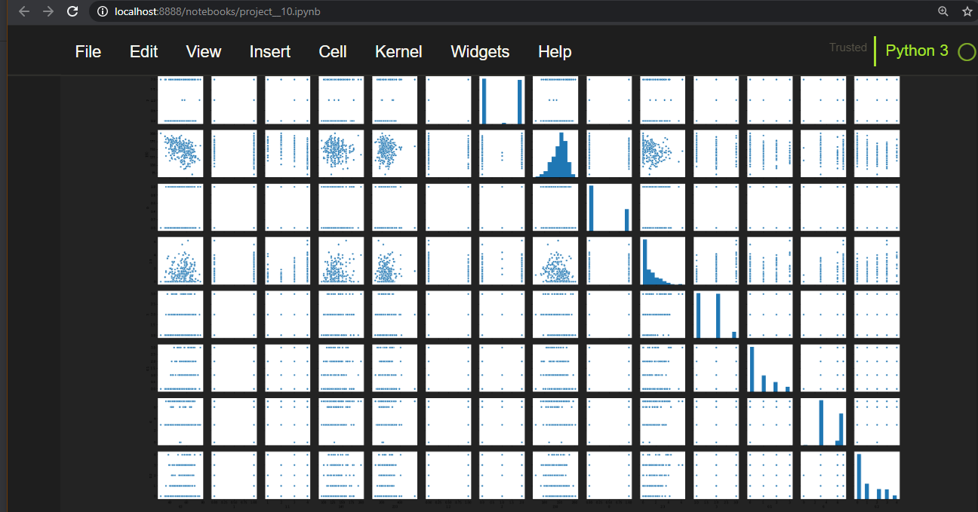

A **boxplot** is a standardized way of displaying the distribution of data based on a five number summary (“minimum”, first quartile (Q1), median, third quartile (Q3), and “maximum”). It can tell you about your outliers and what their values are.

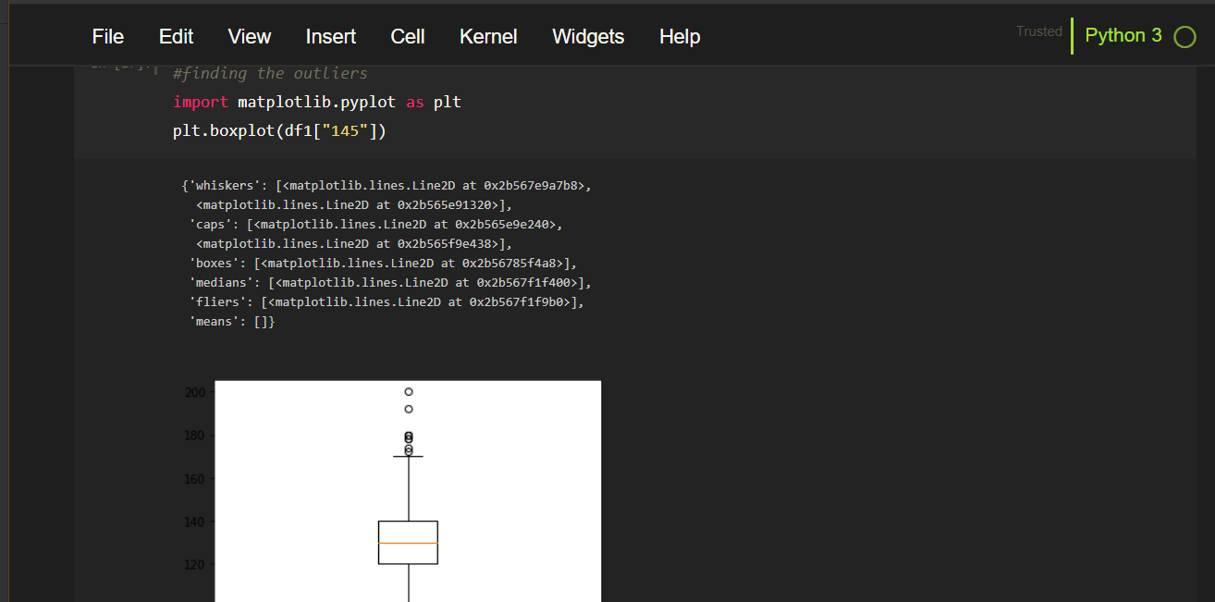

Box plot is also use for detecting the outliers

In this boxplot the points which are above the 75 percentile are considered as outliers.

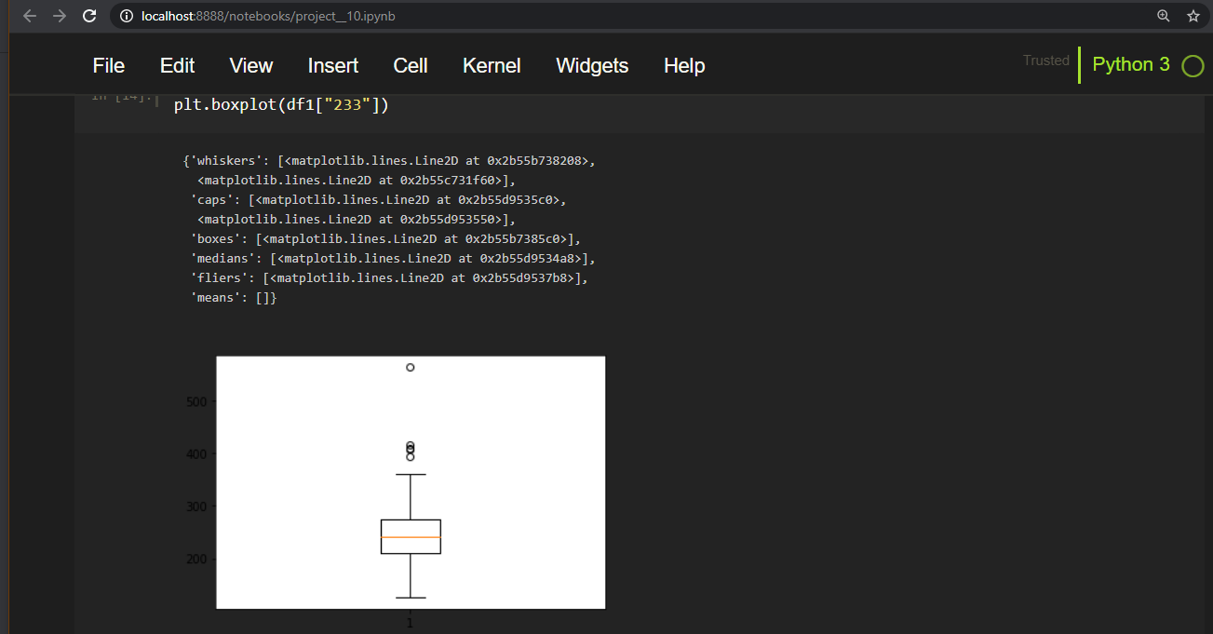



[www.statisticshowto.datasciencecentral.com](http://www.statisticshowto.datasciencecentral.com)

A **Z**-**score** is a numerical measurement used in statistics of a value's relationship to the mean (average) of a group of **values**, measured in terms of standard deviations from the mean. If a **Z**-**score** is 0, it indicates that the data point's **score** is identical to the mean **score**.

In this dataset we are removing the outliers

With the help of zscore

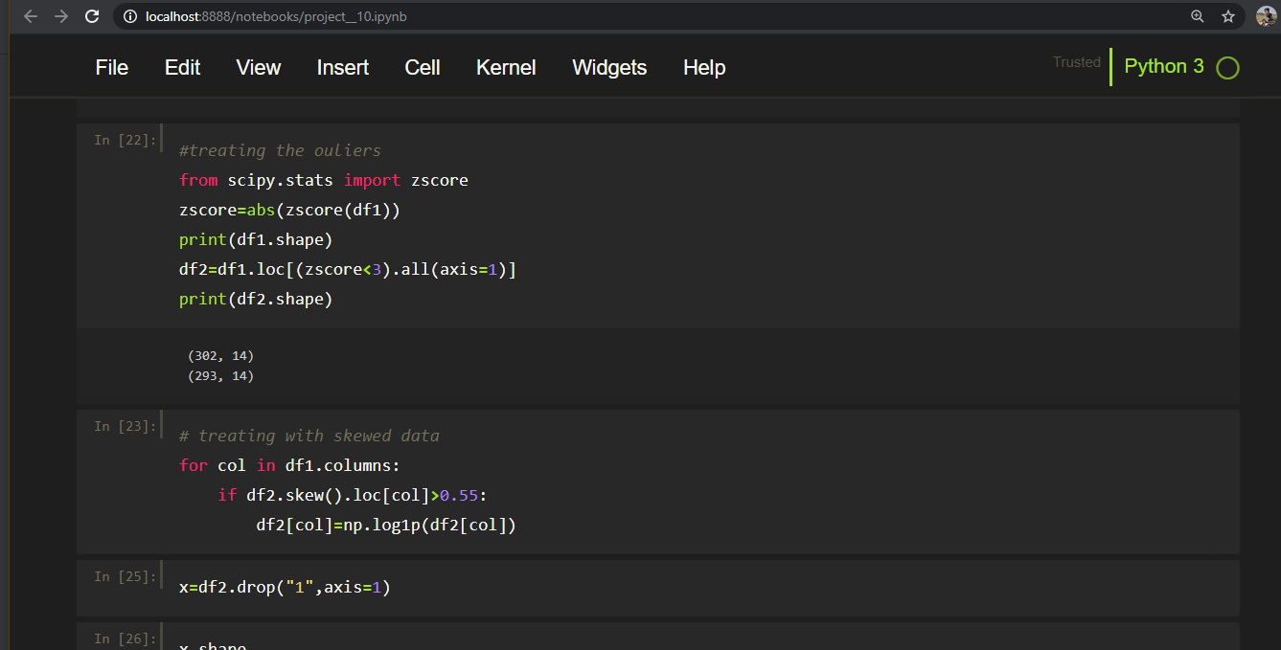

A training dataset is a [dataset](https://en.wikipedia.org/wiki/Dataset) of examples used for learning, that is to fit the parameters (e.g., weights) of, for example, a [classifier](https://en.wikipedia.org/wiki/Classifier_(machine_learning)).[[7]](https://en.wikipedia.org/wiki/Training,_validation,_and_test_sets#cite_note-Ripley,_B.D._1996_p._354-7)[[8]](https://en.wikipedia.org/wiki/Training,_validation,_and_test_sets#cite_note-cann-faq-8)

Most approaches that search through training data for empirical relationships tend to [overfit](https://en.wikipedia.org/wiki/Overfit) the data, meaning that they can identify and exploit apparent relationships in the training data that do not hold in general.

A test dataset is a [dataset](https://en.wikipedia.org/wiki/Dataset) that is [independent](https://en.wikipedia.org/wiki/Independence_(probability_theory)) of the training dataset, but that follows the same [probability distribution](https://en.wikipedia.org/wiki/Probability_distribution) as the training dataset. If a model fit to the training dataset also fits the test dataset well, minimal [overfitting](https://en.wikipedia.org/wiki/Overfitting) has taken place (see figure below). A better fitting of the training dataset as opposed to the test dataset usually points to overfitting.

A test set is therefore a set of examples used only to assess the performance (i.e. generalization) of a fully specified classifier.[[7]](https://en.wikipedia.org/wiki/Training,_validation,_and_test_sets#cite_note-Ripley,_B.D._1996_p._354-7)[[8]](https://en.wikipedia.org/wiki/Training,_validation,_and_test_sets#cite_note-cann-faq-8)

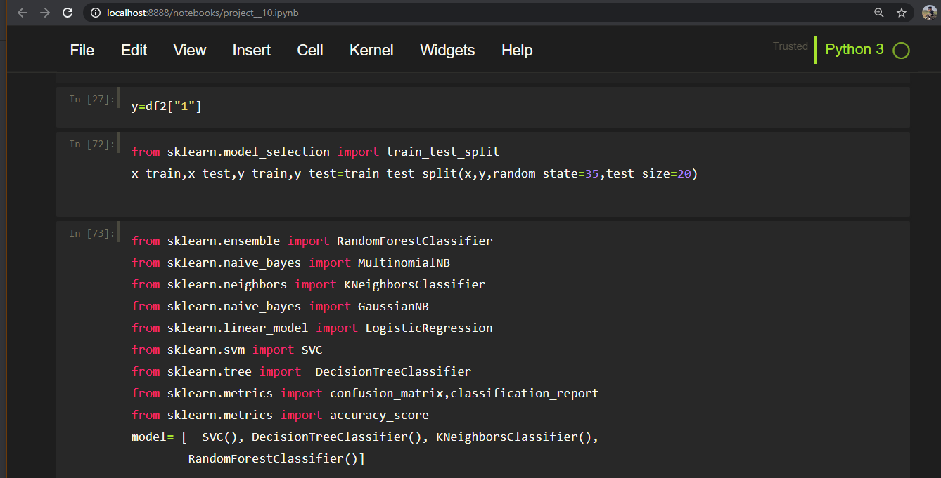

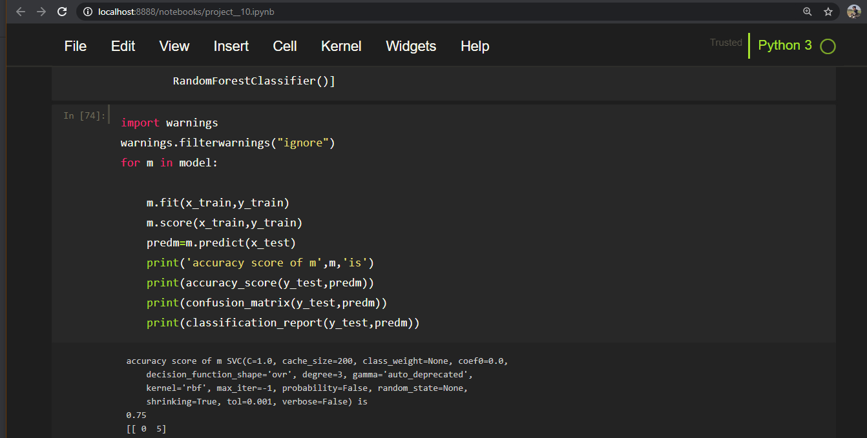

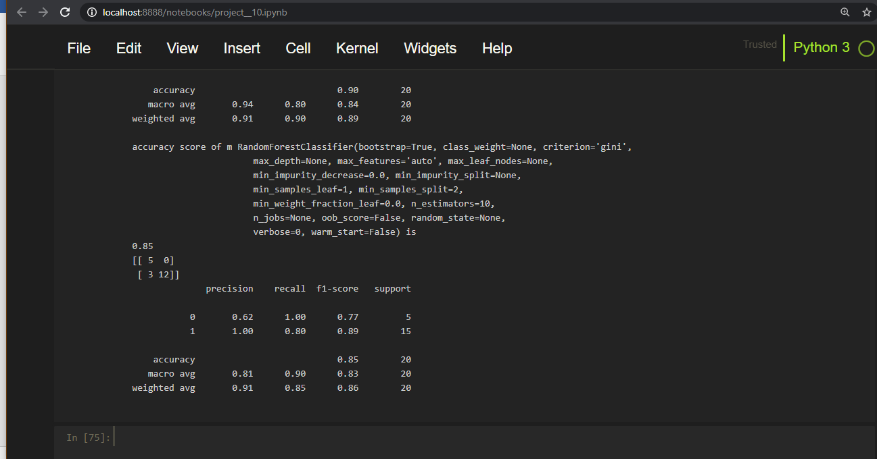

Using different type of classifier model

And getting different accuracy score in each model

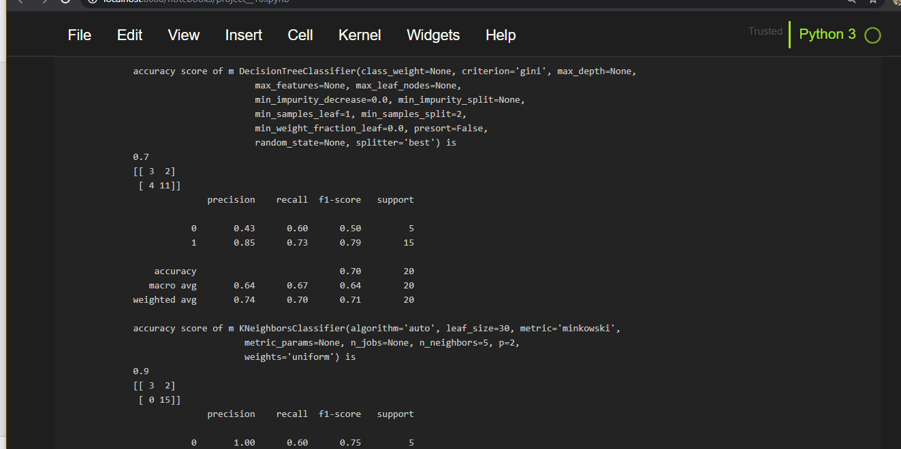

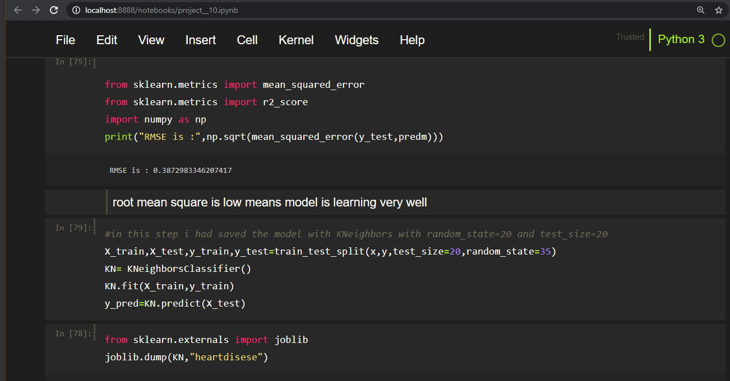

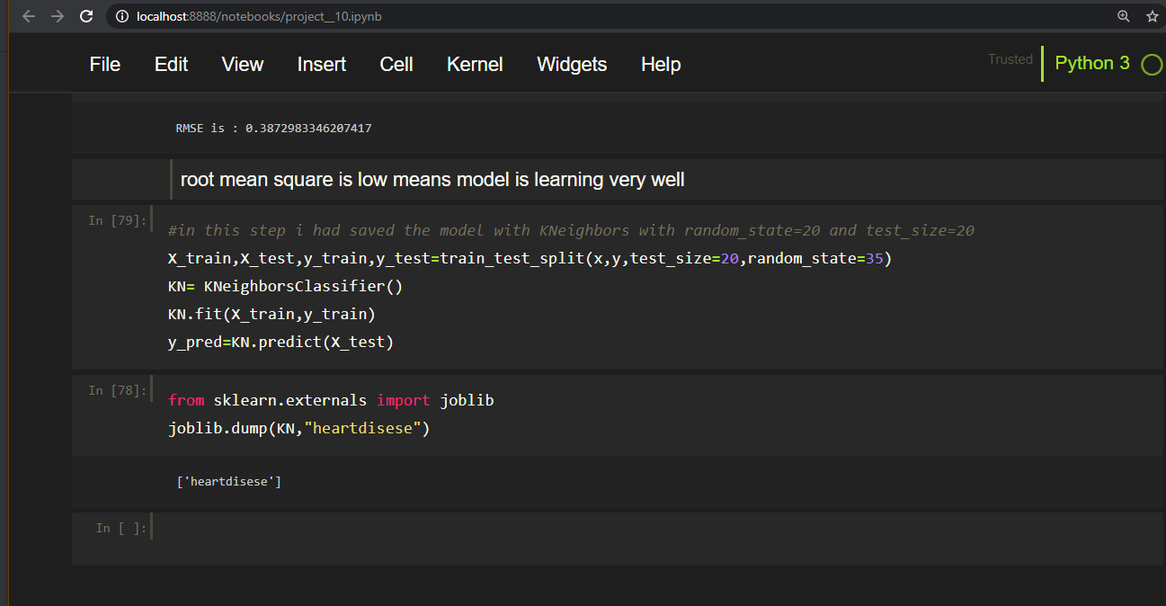

**Joblib** is a set of tools to provide lightweight pipelining in Python. In particular, **joblib** offers: transparent disk-caching of the output values and lazy re-evaluation (memoize pattern) easy simple parallel computing. logging and tracing of the execution.finally save the model with the help of joblib.dump